The $3trn question
The world’s consumers are sitting on piles of cash. Will they spend it?
Households look set to power the economic recovery—especially in America
Mar 13th
The economic controls implemented during the second world war make today’s restrictions on restaurants and football stadiums look lax. In America the government rationed everything from coffee to shoes and forbade the production of fridges and bicycles. In 1943 its entire automobile industry sold only 139 cars. Two years later the war ended, and a consumer-led boom ensued. Americans put to use the personal savings they had accumulated in wartime. By 1950 carmakers were producing more than 8m vehicles a year.

Governments today are slowly easing lockdowns, as vaccines reduce hospitalisations and deaths from covid-19. Attention is turning to the likely shape of the economic recovery. The big question is whether or not the rich world can repeat the post-war trick, with pent-up savings powering a rapid bounce-back.
Households have certainly accumulated lots of cash. The Economist has gathered data on personal saving—the difference between post-tax income and consumer spending—for 21 rich countries. Had the pandemic not happened, households would probably have stashed away $3trn in the first nine months of 2020. In fact they saved $6trn. That implies “excess saving” of about $3trn—a tenth of annual consumer spending in those countries. Households in some places have built up bigger cash piles than those in others (see chart 1). In America excess savings may soon exceed 10% of gdp, in part because of President Joe Biden’s $1.9trn stimulus plan, which was due to be signed into law after The Economist went to press.
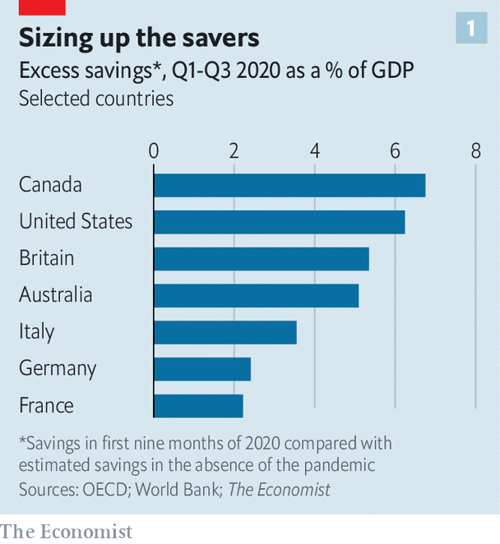
Households do not usually save on such a scale during recessions. For one thing, their incomes usually fall, as their pay is cut or they lose their jobs. But governments in the rich world have spent 5% of their combined gdp on furlough schemes, unemployment benefits and stimulus cheques during the pandemic. As a result, household incomes have actually risen in the past year. At the same time, lockdowns have reduced opportunities to spend.
What will consumers do with the cash? If they were to spend it all in one go, rich-world gdp growth would probably exceed 10% in 2021, a figure so heady it would put the post-war recovery to shame. (It would probably also generate a surge in inflation.) At the other extreme, households could spend none of their savings, perhaps if they anticipated that their tax payments would eventually have to rise in order to pay for the enormous stimulus packages.
The reality will be somewhere in between. Research by JPMorgan Chase, a bank, suggests that in many rich countries consumption will soon rebound to near its pre-pandemic level, powering a strong global recovery. Goldman Sachs, another bank, reckons that in America the spending of excess savings will add two percentage points to gdp growth in the year after full reopening. That points to a fairly rapid recovery in both output and employment. On March 9th the oecd, a rich-country think-tank, upgraded its forecast for gdp growth for the g20 group of countries to 6.2% in 2021, arguing that household savings represented “pent-up demand”.
Such calculations are highly uncertain, however, and not only because there are few precedents apart from the second world war. Two factors matter: how the accumulated pots of cash are distributed across households; and whether people treat those pots as income or as wealth.
Take distribution first. There seems little doubt that in all rich countries wealthier people have accumulated most of the excess savings. They have been the least likely to lose work. A big share of their spending is discretionary, say on holidays or meals out; and it is many of these services that have been shut down during the pandemic. A large chunk of savings in the hands of the rich limits the potential for a post-lockdown spending bonanza because, the evidence suggests, they have a lower propensity to spend what they earn.
Yet the pro-rich skew in savings varies across countries. In many, low-income folk will not have any excess savings to spend, even once lockdowns end. During the pandemic the poorest quarter of European households have been half as likely to increase their savings as the richest. In Britain the worst-off fifth say they have saved less during the pandemic than before. The poorest Canadians have failed to build any nest-eggs in that time.
America looks different. Its fiscal stimulus has been unusually generous. A third round of cheques, for $1,400, will soon be sent to most adults. Top-ups to unemployment benefits have ensured that many people who lost work have earned more from the state than they did in their jobs. The result is that low-income Americans may have saved even more than the rich, relative to their incomes. A new study by the JPMorgan Chase Institute found that in late December the poorest Americans’ bank balances were some 40% higher than the year before, compared with about 25% higher for the richest (see chart 2). The poorest half have seen their liquid assets rise in value by 11% in the past year, nearly twice the increase for the richest 1%. Low- and moderate-income earners are more likely to spend their savings once the economy reopens, fuelling the recovery.
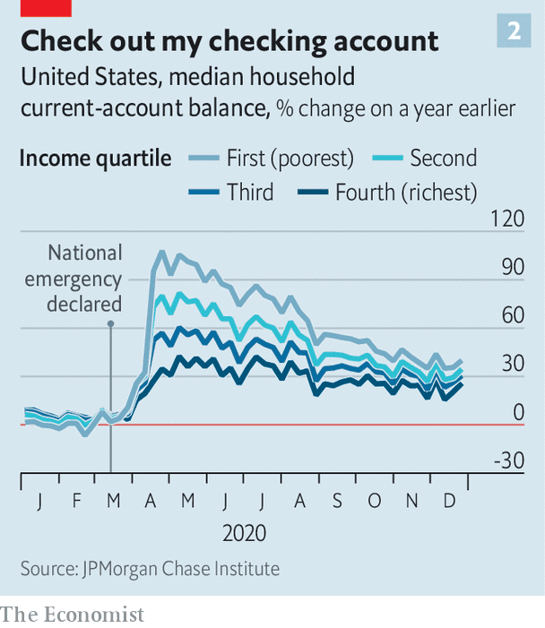
There is greater uncertainty around the second factor influencing the recovery: whether households perceive their cash piles as income or wealth. This is not merely a semantic distinction. Many studies find that households are more likely to boost spending in response to an increase in income (say, a pay rise) than they are for an increase in their wealth (say, a rise in the value of their house). Households have built up excess savings in different ways in different countries. Those in Britain and the euro zone have done so by spending less. People are unlikely to treat this as “additional income”, argued Gertjan Vlieghe, a member of the Bank of England’s monetary policy committee, in a recent speech. In America and Japan, by contrast, excess savings are a result of higher income because of stimulus payouts, not spending cutbacks. In that situation, Mr Vlieghe said, excess saving “can more reasonably be interpreted as ‘additional income’”, which consumers may be happier to spend.
And that points to a striking contrast with the post-war boom. America’s recovery was impressive enough, but Europe’s was even more so, with gdp growth running 50% faster throughout the 1950s. This time is different. As the pandemic wanes it is America, where more stimulus is in place and where consumers are likelier to spend it, that seems set to leave the rest of the rich world in its dust. ■

Joe Biden’s stimulus is a high-stakes gamble for America and the world
It is part of a three-pronged economic experiment
Mar 13th 2021
When the pandemic struck it was natural to fear that the world economy would stay in the doldrums for years. America is defying such pessimism. Having outrun gloomy growth forecasts from last summer, it is adding fiscal rocket fuel to an already fiery economic-policy mix. President Joe Biden’s $1.9trn stimulus bill, which he was poised to sign into law after The Economist went to press, takes to nearly $3trn (14% of pre-crisis gdp) the amount of pandemic-related spending passed since December, and to about $6trn the total paid out since the start of the crisis. On current plans the Federal Reserve and Treasury will also pour some $2.5trn into the banking system this year, and interest rates will stay near zero. For a decade after the global financial crisis of 2007-09 America’s economic policymakers were too timid. Today they are letting rip.
The probable result is a bounce-back that was unthinkable in the spring of 2020. In January America’s retail sales were already 7.4% higher than a year earlier, as most Americans received $600 cheques from the government, part of the previous round of stimulus. Stuck at home and unable to spend as much as they normally would in restaurants, bars and cinemas, consumers have accumulated $1.6trn in excess savings during the past year. Mr Biden’s stimulus gives most Americans another $1,400 each. Unusually for a rich country, a big chunk of the cash pile is held by poor households that are likely to spend it once the economy fully reopens. If vaccines continue to reach arms and America avoids a nasty encounter with new variants, the unemployment rate should fall comfortably below 5% by the end of the year.
The good news is not confined to America. Manufacturing surveys are healthy even in the euro zone, which is behind on vaccinations and battling new variants, and is applying less stimulus. Mr Biden’s spending will further boost global demand for goods. America’s trade deficit is already more than 50% greater than before the pandemic, as the economy sucks in imports. But the rest of the world will not match Uncle Sam’s breakneck pace. On March 9th the oecd, a club of rich countries, forecast that America’s economy will, uniquely among big economies, be larger at the end of 2022 than it had been predicting before the pandemic. From April to September America is likely to outgrow even China, which is tightening monetary policy and has suffered a 9% fall in its stockmarket since mid-February.
Surging out of a crisis that had at its worst moment cut the number of people in work by 15% will be a triumph for America, and will stand in contrast to the puny recovery after the financial crisis. Mr Biden’s spending will provide welcome relief to those whose lives have been upended—today America is still missing 9.5m jobs. Thanks to extra cash for most parents, the country’s persistent and widespread child poverty will fall dramatically.
Yet, though today’s policymakers have a guaranteed place in economic history, they may not come to be seen as heroes. That is because America is running an unpredictable three-pronged economic experiment that features historic levels of fiscal stimulus, a more tolerant attitude at the Fed towards temporary overshoots in inflation, and huge pent-up savings which no one knows if consumers will hoard or spend. This experiment has no parallel since the second world war. The danger for America and the world is that the economy overheats.
It is a risk that investors have been weighing up. America’s ten-year bond yields, which move inversely against prices, have risen by about one percentage point since last summer, on expectations of higher inflation and higher interest rates. Because of America’s pivotal role in the global financial system, its outlook for monetary policy spills across borders. In recent weeks Australia’s central bank has had to increase its bond purchases to prevent yields from rising too much. The European Central Bank was deciding whether to make a similar intervention as we went to press. Emerging markets with big deficits, like Brazil, or with large dollar-denominated debts, like Argentina, have reason to fear the tightening in global financial conditions following a turn in American monetary policy.
The Fed is adamant that it will keep interest rates low and continue to buy assets until the economy is much healthier. Inflation will inevitably rise as a collapse in commodities prices early in the pandemic falls out of comparisons with a year earlier, but the Fed will ignore this. Under its new “average inflation targeting” regime, adopted last year, it is seeking to bring about inflation over its 2% target in order to make up for past shortfalls. That is particularly desirable because, for much of the past decade, the world economy’s problem has been too little inflation, not too much. Even if the economy eventually overheats, Jerome Powell, the Fed’s chairman, has argued that this, too, will be temporary. Longer-term inflation dynamics, he argues, “don’t change on a dime”.
Might they, however, turn on trillions of dollars? We have no reason to doubt the Fed’s near-term plans, but neither it nor the markets can predict the eventual outcome of America’s experiment. The Fed might have to pour cold water on the economy, raising interest rates to get inflation down. That would be awkward, given how much it has recently emphasised its obligation to seek “broad based and inclusive” strength in the jobs market. Higher rates would puncture asset markets and might also precipitate conflict with an increasingly indebted government.
All the chips on red
Mr Biden’s stimulus is a big gamble. If it pays off, America will avoid the miserable low-inflation, low-rate trap in which Japan and Europe look stuck. Other central banks may copy the Fed’s new target. Massive fiscal stimulus may become the normal response to recessions. The risk, however, is that America is left with rising debts, an inflation problem and a central bank facing a test of its credibility.
This newspaper would have preferred a smaller stimulus. Alas, America’s troubled politics do not permit fine-tuned policymaking and Democrats wanted all they could get. Mr Biden’s gamble is better than inaction. But nobody should doubt the size of his bet
Fiscal stimulus
Why Joe Biden’s proposed stimulus is too big
America’s economy needs targeted relief more than indiscriminate spending
Feb 6th 2021
America’s economy will recover faster from the pandemic than its rich-world peers, the imf predicts. Not because it has controlled the spread of disease—it hasn’t—but mostly because of its enormous economic stimulus, which boosted household incomes by more than 6% in 2020 even as the unemployment rate peaked near 15%. Before Joe Biden became president, Congress had already spent $4trn fighting the crisis. Now he proposes $1.9trn more emergency spending, which would take the total to over 25% of gdp in 2019. Republicans think that is too much. A group of the party’s senators has made a counter-offer of a plan worth about $600bn (see article).
The right size for the bill is not best judged from the top down. America is not in a normal recession that is best solved by a calibrated slug of government spending. No amount of pump-priming will fully reopen restaurants, nightclubs and offices while the virus remains prevalent—nor would that be desirable. The government must instead fight the crisis from the bottom up.
Congress should spend whatever is needed on vaccinations and on replenishing the incomes of workers bearing the brunt of the crisis. They have lost their jobs through no fault of their own, and if their incomes collapsed, they would slash their spending, spreading the pain to the rest of the economy. Extending a generous top-up to unemployment-insurance benefits beyond its expiry in March should be a priority.
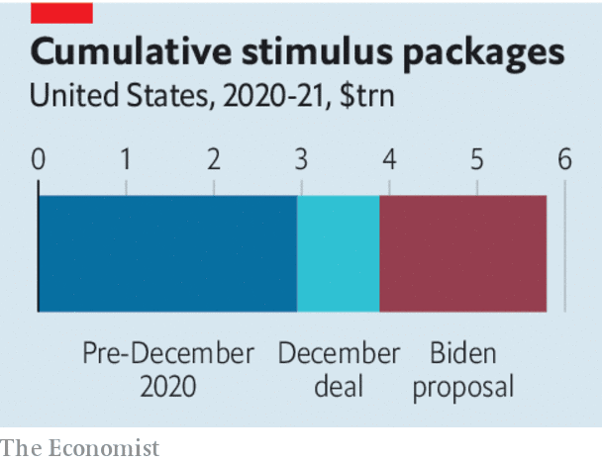
Nobody should fret about the cost of providing what is in effect disaster relief. Prolonging vast deficits, however, does carry a risk. According to official projections released on February 1st, without more stimulus America’s gdp would lag behind its potential by only 1.3% at the end of 2021. Mr Biden’s proposed spending is six times bigger than the shortfall. The “multiplier” effect of government spending on output is hard to estimate, but is small today because many households are saving stimulus money. Yet should vaccinations let the economy reopen fully in the second half of 2021, the pent-up effects of stimulus may cause the economy to overheat, leading to a burst of inflation.
Higher inflation would be tolerable—welcome, even, up to a point. But it would mean any further deficit spending, for example on Mr Biden’s infrastructure plan, would further stoke the fire. Better to preserve fiscal fuel by avoiding unnecessary largesse. Democrats want to send cheques worth $1,400 to most individuals, adding to the $600 they recently received. Universal handouts stop people falling through the cracks of bureaucratic means-tested programmes, but $2,000 is an arbitrary total popularised by Donald Trump. Mr Biden’s plan also includes $350bn for state and local governments. Early in the crisis it looked as if they would suffer a collapse in tax revenues. In fact, their budgets have held up as the federal government’s generous unemployment benefits and a burst of spending on goods have boosted their tax receipts. Neither of these items in Mr Biden’s bill is a priority.
The right fiscal policy would be flexible, providing emergency spending for as long as the pandemic persists and saving a broader fiscal boost for later if necessary. Republicans—and some moderate Democrats—are right to argue that $1.9trn is excessive today. Mr Biden may be willing to trim his proposal. A figure of around $950bn would allow for unemployment insurance, a smaller amount of catch-all universal cheques, Mr Biden’s assault on child poverty and extra spending on vaccines.
Equally, Democrats are right to fear that hawks in Congress could derail the recovery if the crisis worsens. Republicans should pledge to support further spending were that to happen. The Democrats should husband their limited opportunities to circumvent Republican opposition in the Senate. A bipartisan agreement now will raise the odds that the economy will get the right amount of support at the right time.

Will Joe Biden’s fiscal stimulus overheat the American economy?
If it does, higher inflation could be the consequence

Jan 19th 2021
On January 20th Joe Biden entered the White House during an economic crisis for the second time. On January 14th he unveiled his plan for dealing with the downturn wrought by the pandemic. Viewed from the bottom up, it combines vital spending on vaccines and health care, needed economic relief and other, more debatable handouts. Seen from the top down, it is a huge debt-funded stimulus. Mr Biden’s plan is worth about 9% of pre-crisis gdp, nearly twice the size of President Barack Obama’s spending package in 2009. And it is big, too, relative to the shortfall in demand that America might suffer once it puts the winter wave of covid-19 behind it, given the stimulus already in place.
A natural question to ask, then, is whether the proposal, admittedly an opening gambit in a negotiation with Congress, might overheat the economy if implemented. The most prominent figure to warn that this may happen is Larry Summers of Harvard University. His criticisms are notable both because he was an adviser to Mr Obama and because he was hitherto perhaps the world’s foremost advocate of deficit spending. “If we get covid behind us, we will have an economy that is on fire,” he said on January 14th.
There are three main reasons to suspect overheating might be on the cards: emerging evidence that the downturn may prove temporary; generous stimulus; and the Federal Reserve’s monetary-policy strategy. Take first the evidence that today’s downturn might be more temporary hiatus than prolonged slump. The number of non-farm jobs remains around 10m, or 6.3%, below its pre-pandemic peak—similar to the shortfall seen in 2010. Yet after the first wave of infections last year, unemployment fell much more rapidly than forecasters expected. If job creation were to return to the average pace achieved between June and November 2020, the pre-pandemic peak in employment would be reconquered in less than a year. It was not until midway through Mr Biden’s second vice-presidential term that such a milestone was reached last time.
Bolstering the case for a rapid rebound is the fact that economic disruption appears concentrated in certain sectors, rather than spread widely. America shed jobs, on net, in December, but only because the leisure and hospitality industries were hit by social distancing. The ratio of job openings to unemployed workers remains high and, outside the affected sectors, wage growth has not fallen much. The shortfall in spending is also concentrated. Consumer spending in the week to January 3rd was down by just 2.8% compared with a year earlier, according to Opportunity Insights, a research group. Yet retail spending on goods was 16.5% higher; it is restaurants, transport and entertainment that are in trouble. And stimulus has more than made up the disruption to incomes in 2020. In November Americans’ total after-tax income was 4.3% higher than a year ago.
Indeed, the arithmetic of stimulus is a second reason why the economy may heat up. Before December, total fiscal stimulus in 2020 amounted to almost $3trn (about 14% of gdp in 2019), much more than the probable fall in output. Social-distancing measures meant that much of this cash piled up in bank accounts. According to Fannie Mae, a government-backed housing-finance firm, by mid-December Americans had accumulated about $1.6trn in excess savings. It is hard to know what might happen to this cash pile; economists typically assume that households are much less likely to spend wealth windfalls (such as the gains from a rise in the stockmarket) than income. But if people instead regard these excess savings as delayed income, then the cash hoard represents stimulus that has not yet gone to work, to be unleashed when the economy fully reopens.
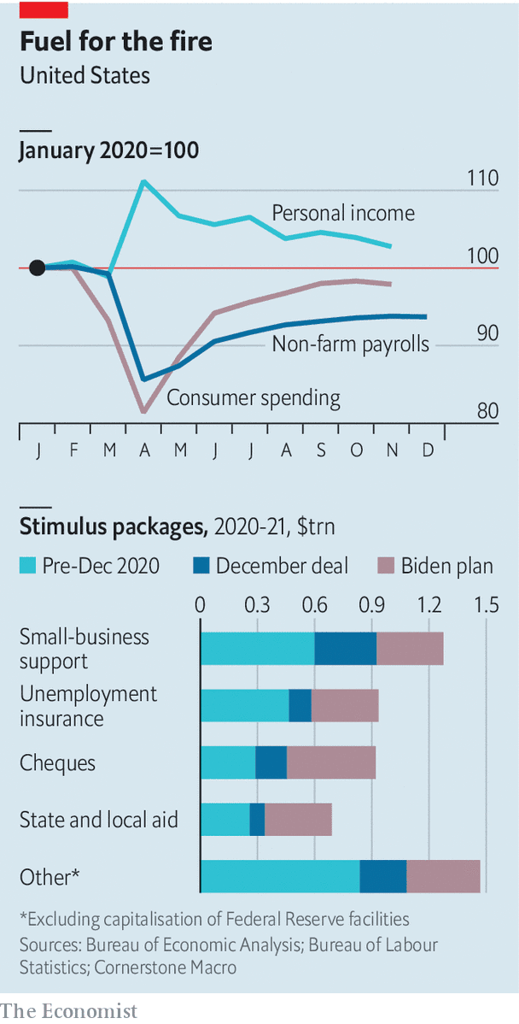
In December President Donald Trump signed into law another $935bn of deficit spending, which extended unemployment benefits, provided more support for small firms, and sent most Americans a cheque for $600. This ensured that lost income would continue to be replaced. Mr Biden’s proposed $1.9trn of stimulus, which includes another $1,400 in cheques, would make the total fiscal boost in 2021 roughly equal to that in 2020.
Jason Furman, another former Obama adviser, calculates that the combined impact of the December package and the Biden plan would be about $300bn per month for the nine months in 2021 for which the measures will be in effect. By comparison, the shortfall in gdp, compared with its pre-crisis trend, was only about $80bn in November. Typically, Keynesians argue that fiscal stimulus boosts the economy because of a sizeable “multiplier” effect. But the case for the stimulus to be as large as Mr Biden’s proposal “has to be that you think the multiplier in 2021 is really small”, says Mr Furman. Otherwise, it seems destined to take total spending in the economy beyond what it can produce next year, resulting in a burst of inflation.
Were the economy to show signs of such overheating, the Fed might typically be expected to raise interest rates to cool things down. Indeed, since January 6th, when the Democrats won the crucial Senate seats in Georgia that might allow them to pass a big stimulus, the ten-year Treasury yield has risen from about 0.9% to around 1.1%. The yields on inflation-linked bonds have risen roughly commensurately, suggesting that bond investors have been expecting higher real interest rates, rather than just higher inflation.
But the Fed is tripping over itself to signal that monetary policy will remain loose—a third reason to expect overheating. The time to raise interest rates is “no time soon”, said Jerome Powell, its chairman, on January 14th. He also pooh-poohed the idea that the Fed might soon taper its $120bn monthly purchases of Treasuries and mortgage-backed securities. Mr Powell says the Fed has learned the lessons of 2013, when its hints that it might taper asset purchases sent bond markets into a tizz. Monetary policymakers still say that preserving “smooth market functioning” is one of the goals of their purchases, even though no dysfunction has been seen in bond markets since the spring.
The Fed is so willing to keep the pedal to the metal because, in contrast to the recovery from the financial crisis, it is seeking to overshoot its 2% inflation target, in order to make up for continuing shortfalls. The strategy, announced last summer, is still being digested by investors. It is unclear whether policymakers are committed to “average inflation targeting” as an end in itself, or simply as a means to stop inflation expectations from slipping too much during the downturn, argues David Mericle of Goldman Sachs, a bank. Given that inflation expectations have risen recently, that distinction might prove important. Regardless, the Fed has been clear that it will not raise rates until inflation is “on track to moderately exceed 2% for some time”.
Those who are zealously committed to breaking the world economy out of the low-rate, low-inflation trap of the 2010s might welcome the even larger burst of inflation that the current fiscal and monetary policy mix could enable. The Fed, however, is not in that camp. Were overheating to provoke it into earlier rate rises than markets expect, the assumption of cheap money that underpins today’s sky-high asset prices and the sustainability of rocketing public debt might begin to unravel.
Such a scenario remains a tail risk. The most likely outcome is that Congress agrees on a smaller stimulus than Mr Biden has proposed, and that overheating, if it occurs, proves temporary. Beyond that, nobody really knows how fast the economy can grow without setting off inflation. Should economic policy stay in uncharted territory, though, its speed limits may be tested more frequently

US Congress injects a further $900bn of stimulus into the American economy

Jan 2nd 2021
One in eight American adults in December reported going hungry during the previous week. This was, according to the Census Bureau’s regular surveys, the worst result of the final three months of 2020. That tracked other measures of financial distress—the share of Americans estimated to be in poverty or reporting difficulties paying for housing—which have increased as the covid-19 epidemic entered a third, wintry phase and chilled the economic recovery. The burden has been felt most by the disadvantaged: in households with less than $25,000 in income, 32% of adults reported having to miss meals in the past seven days. More than 40% of black and Hispanic renters have little to no confidence in being able to pay for housing in the coming month.
All this—to say nothing of the death toll of the virus, which is now above 330,000—got worse while Congress debated for seven months whether the economy needed more support. The big fiscal stimulus passed in March, costing $2.2trn, made a real and measurable dent in hardship in the first months of virus-induced lockdowns. One-time cheques of $1,200 for most American adults and generous top-ups of $600 a week to unemployment benefits were part of a temporary experiment with a European-style safety-net. Government expenditure in 2020 increased by about 50% compared with the previous year, easily the greatest increase since 1963, when the Congressional Budget Office started counting. The result was that the savings rate among families went up, not down. Poverty was probably cut by 15%, the biggest one-off reduction recorded since measurement began.
Many of the provisions in that first stimulus expired in the summer of 2020, as Democrats and Republicans failed to reach an agreement on a successor stimulus bill. Poverty crept back up beyond its old levels. The impasse was broken only after the presidential election was (mostly) past, and as negotiations were tied to legislation needed to keep the federal government open. At the last possible moment, days before the end of the legislative term, a compromise was reached.
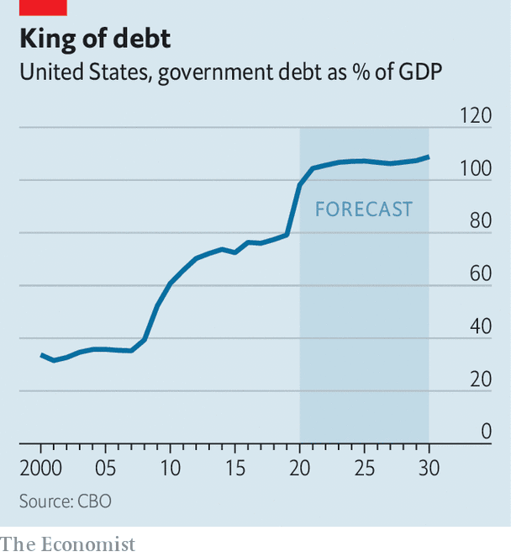
Frantic negotiations led to a 5,600-page piece of legislation to spend $900bn released only a few hours before it was passed by large majorities of both chambers. It is more modest than the previous stimulus. The weekly top-up to unemployment benefits will be $300, and these payments will only go on until March. Another round of cheques, worth $600 this time, will be disbursed to most Americans. A moratorium on evictions will be extended, though it is not clear what will happen to the mountain of rent arrears or what compensation is owed to landlords.
President Donald Trump, self-proclaimed master of the art of the deal, will close out his presidency having never abandoned the role of bit-player to the various legislative dramas of his term—from the failed attempt to repeal Obamacare, to the tax cuts passed in 2017, to the spending bonanza triggered by covid-19. Still, his final performance should take the prize for buffoonery. The day after Steven Mnuchin, the treasury secretary and the president’s chief negotiator, called the bill “fabulous” as it passed Congress, Mr Trump decided that it was really a “disgrace” and suggested he would veto it unless the cheques were supersized to $2,000 per American. This red line had not been mentioned by the White House as it was negotiating with Democrats in Congress; the excessive spending on foreign aid that Mr Trump also expressed disdain for was the same amount his budget office had called for in its request to lawmakers.
Having vented his frustration with Congress (and especially with Republicans who are only lukewarmly entertaining his efforts to overturn his election loss), Mr Trump relented and signed the legislation on December 27th, two days before the federal government would have shut down. The deal-master’s tantrum was not without consequence, though. He has put Mitch McConnell in a bind: the Senate Majority leader would rather not have a vote on increasing the cheques to $2,000, as the president is still calling for, making him a target of the presidential Twitter feed.
Only a few more weeks of Mr Trump’s drama remain. For Joe Biden, the president-in-waiting, the new stimulus sets the initial economic conditions for his administration. It is a short window. The enhanced unemployment benefits will expire before his first 100 days are up, and probably before widespread vaccination triggers an economic recovery. Mr Biden has expressed interest in a subsequent round of stimulus, perhaps one tethered to a green infrastructure programme, but his legislative leverage may prove limited.
In approximately three weeks’ time, Republicans are likely to become overwhelmingly concerned with the federal deficit and the national debt (which ballooned during the Trump administration). This will be the main cudgel used to clobber Mr Biden’s policy ambitions. Indeed, this is likely to be the final round of stimulus if Democrats fail to flip two Senate seats in Georgia, which will be decided by a run-off election on January 5th.
In the ideal version of American politics, economic-recovery legislation would be proportionate to crisis indicators, not the partisan affiliations of elected officeholders. Hunger and housing insecurity need to start subsiding before the need for additional support to households is ruled out. As the year of lost learning for many American pupils starts to register in standardised-test results, a programme of tutoring to make up lost ground may be necessary. In reality, the rapidly constructed European-style safety-net is time-limited. Covid-19 has highlighted, again, how desirable it would be to for stimulus measures to kick in automatically when the economy is weak. The seven months of will-they-won’t-they brinkmanship make the current approach suboptimal. But Congress has managed to pass a stimulus, while also showing how poverty might be reduced in future. That is something to cheer

